AIT 524: Weekly Assignment 07
Tanmoy Chowdhury
George Mason University

Author Note
This task is being submitted as an assignment task for the course ‘Database Management Essential’ offered in Sprig 2018. For any kind of inquiry, feel free to contact at tchowdh6@masonlive.gmu.edu.

Hands-On Assignment

- Display a list of all data contained in the BOOKS table

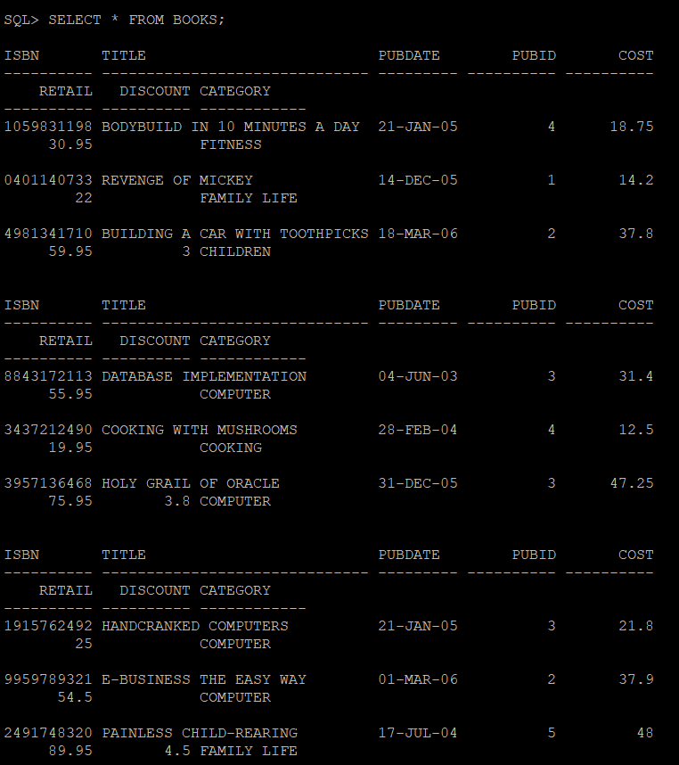
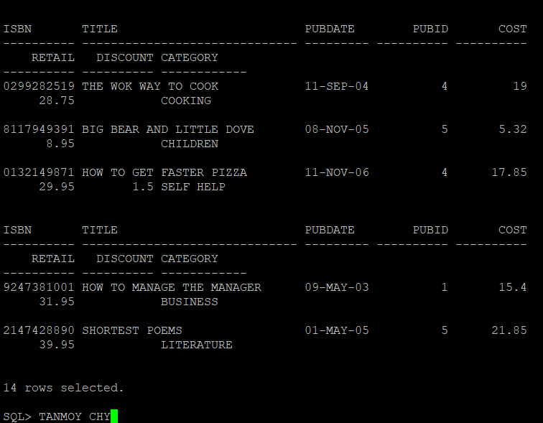

- List the title only of all books available in inventory, using the BOOKS table.

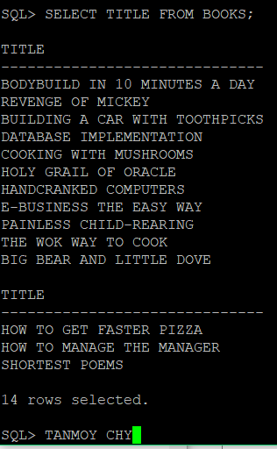

- List the title and publication date for each book in the BOOKS table. Use the column heading “Publication Date” for the Pubdate field.
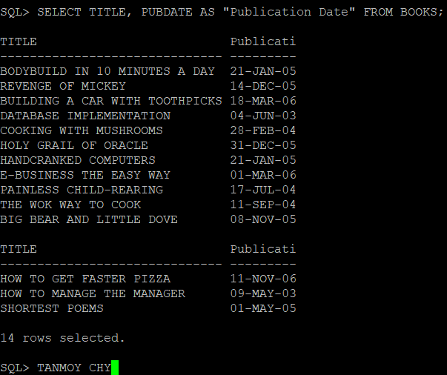

- List the customer number for each customer in the CUSTOMERS table, along with the city and state in which the customer lives
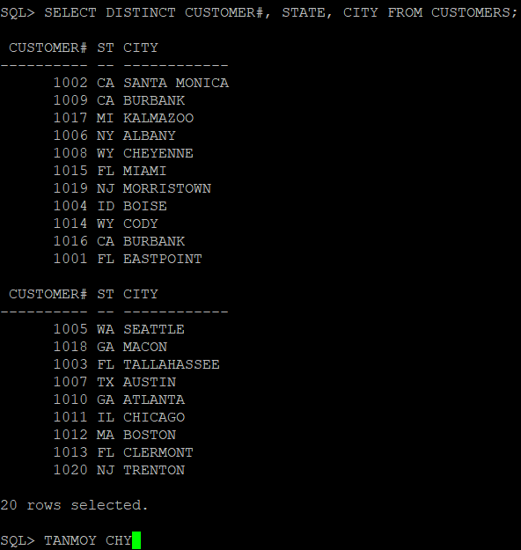

- Create a list containing the publisher’s name, the person usually contacted, and the publisher’s telephone number. Rename the contact column “Contact Person” in the displayed results. (Hint : Use the PUBLISHER table.)
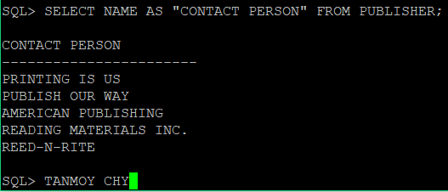
- Determine which categories are represented in the current book inventory. List each category only once.
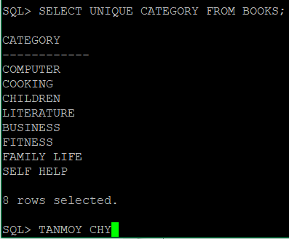

- List the customer number from the ORDERS table for each customer who has placed an order with the bookstore. List each customer number only once.
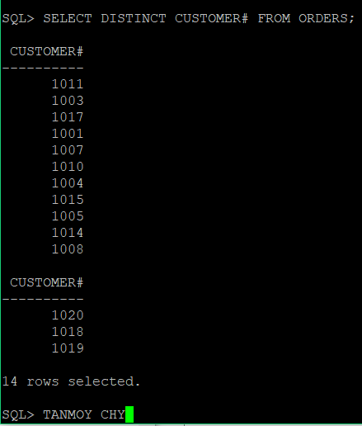

- Create a list of each book title stored in the BOOKS table and the category in which each book belongs. Reverse the sequence of the columns so that the category of each book is listed first.
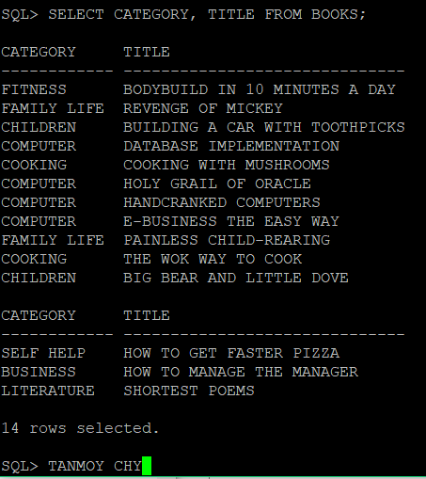

- Create a list of authors that displays the last name followed by the first name for each author. The last names and first names should be separated by a comma and a blank space.
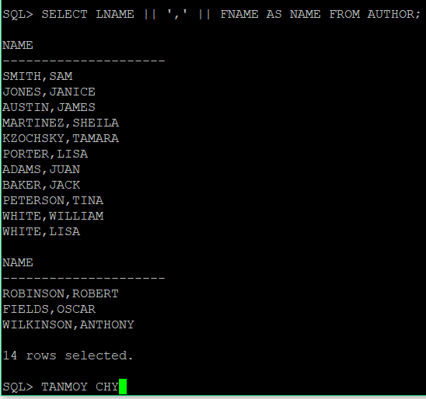

- List all information for each order item. Include an item total, which can be calculated by multiplying the Quantity and Paid each column. Use a column alias for the calculated value to show the heading “Item Total” in the output.
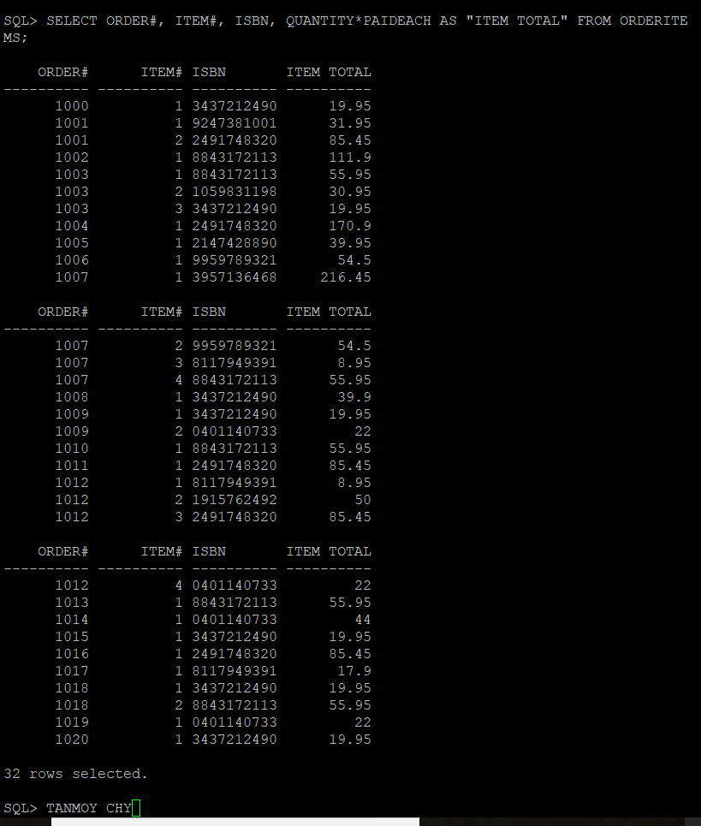

References
Casteel, J. (2016). Database system concepts and architecture in M. J. Horton, Oracle® 12c: SQL : Cengage Learning.

